MINIMUM VAULT SIZE
 | A | B | C
4” | 36” | 36” | 24”
6” | 42” | 48” | 30”
8” | 48” | 48” | 30”
10” | 48” | 60” | 42”
DEPTH VARIES
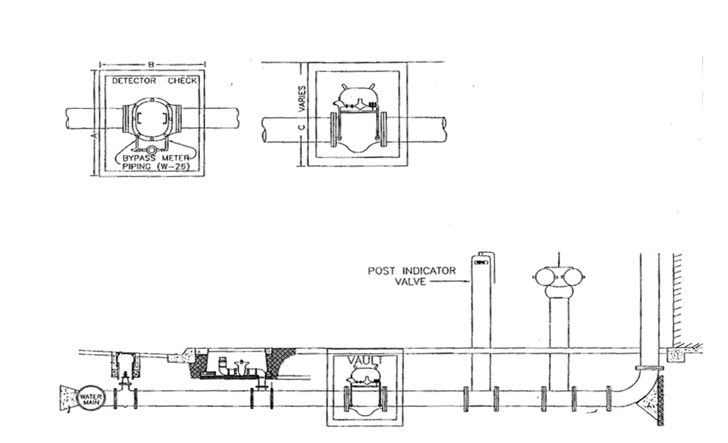
Top of FDC 18” to 48”
Within 35’ of Fire Hydrant

FIRE DEPARTMENT
CONNECTION

NOTES
- DETECTOR CHECK VALVE TO BE AN AMES 1000
OR FEBCO MODEL 800 OR APPROVED EQUAL.
- CHECK VALVE TO BE TAPPED AND PLUGGED FOR INSTALLATION OF BYPASS METER PIPING.
- VAULT TO BE CRISTY, BROOKS OR APPROVED EQUAL.
- VAULT TO PROVIDE MINIMUM OF 12” CLEARANCE AROUND CHECK AND BYPASS METER.
- VAULT, DETECTOR CHECK VALVE AND VAULT COVER TO BE INSTALLED BY DEVELOPER / CONTRACTOR AS PER STD 2.1.

Clovis Fire Department Standard 2.1
Fire Sprinkler Underground
SIDEWALK

CURB & GUTTER

VALVE BOX

CONCRETE THRUST BLOCK PER NFPA 24

THIS AREA REQUIRES CITY ENGINEERING APPROVAL

THIS AREA REQUIRES FIRE DEPARTMENT APPROVAL

Top of PIV 32” to 40”

FIRE SERVICE LINE

DETECTOR CHECK VALVE

RISER

